ELEC 344

Lab Experiment: #1

Section: L1E

Bench #: 6

Partners | Student ID | % participation | Signatures
Thomas Bement | 24099822 | 50
Brian Nguyen | 39005590 | 50

Date Performed:

Date Submitted:

Task 1 A: Measurements with RL Load Box
Table 1: Single phase parallel inductors
Measurement | 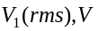 | 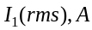 | 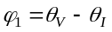 | 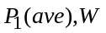 | 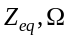 | 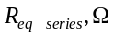 | 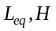
one inductor | 17 | 0.88 | (-1.4) – (-87) | 1.2
three inductors | 17.01 | 2.58 | (-1.4) – (-86.9) | 3.5

- How is this inductor different from an ideal inductor element?
The inductor likely also has some internal resistance.

- Are the calculated values of inductance close to the expected value? What is the difference?
40 MH inductor
40 uF cap

Task 1 B: Measurements with RC Load Box
Table 2: Single phase parallel capacitors
Measurement |  |  |  |  |  | 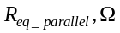 | 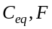
one capacitor | 15.01 | 0.25 | (-6.6) – (83.2) | 0
three capacitors | 15 | 0.71 | (-6.0) – (83.4) | 0

- How is this capacitor different from an ideal capacitor element?

- Are the calculated values of capacitance close to the expected value? What is the difference?

Task 1 C: Parallel connection of RLC components
Table 3: Parallel connection of RLC components. Supply voltage V1 = 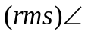
Measurement |  |  | 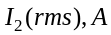 |  | 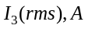
one resistor
and
,,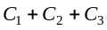

- How has the real power changed when you connected inductors and capacitors in parallel?

- How are the magnitudes of the currents I1, I2, and I3 related to each other when all elements are connected in parallel?

- Can either I2 and/or I3 have magnitude larger than the magnitude of I1? Explain.

Task 1 D: Series connection of RLC components
Table 4: Series connection of RLC components. Supply voltage V1 =
Measurement |  |  | 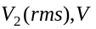 |  | 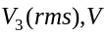
,,
,,
,,,,

- How has the real power changed when you connected capacitors in parallel or resistors in parallel?

- How are the magnitudes of voltages V1, V2, and V3 related to each other when all elements are connected in series?

- Can either V2 and/or V3 have magnitude larger than the magnitude of V1? Explain.

- Support your answer with the phasor diagram corresponding to the measurement Task 1 D, step 5).

Task 2 A: Three-Phase Measurements with Y-connected RL Load Box

Table 5: Balanced and unbalanced Y-connected RL three-phase load.
Measurement | 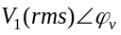 | 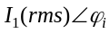 | 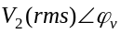 | 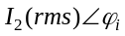 | 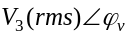 | 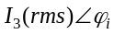 | 
RL balanced load, neutrals disconnected
(save waveforms)
RL unbalanced load, shorted resistor, neutrals disconnected
RL unbalanced load, shorted inductor, neutrals disconnected
(save waveforms)
RL unbalanced load, shorted resistor, neutrals connected
RL unbalanced load, shorted inductor, neutrals connected
(save waveforms)

- How close your measurements are to the ideal case when the RL load is balanced?

- What happens to the phase voltages and currents when the resistor is shorted in one of the phases?

- What happens to the phase voltages and currents when the inductor is shorted in one of the phases?

- How does connecting or disconnecting the Neutral Wire affect the phase voltages and currents when the load is unbalanced?

Task 2 B: Three-Phase Measurements with Delta-connected RL Load Box

Table 6: Balanced and unbalanced Delta-connected RL three-phase load.
Measurement
RL balanced load
RL unbalanced load, shorted resistor
RL unbalanced load, shorted inductor

- How close your measurements are to the ideal case when the RL load is balanced?

- How do the current and power measurements (values) compare with the previous case when the balanced load was Y-connected?

- What happens to the phase voltages and currents when the resistor is shorted in one of the phases?

- What happens to the phase voltages and currents when the inductor is shorted in one of the phases?

- The load circuit in Task 2B and Task 2C are identical in each step. Compare the measurements of currents and voltages of Task 2B and Task 2C. Explain the results.

- Compare the measurements of real power of Task 2B and Task 2C. Explain the results.

